Cc 2017

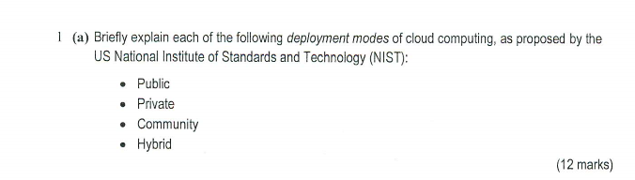

Public：

The **public cloud** is defined as computing services offered by third-party providers over the **public**Internet, making them available to anyone who wants to use or purchase them. They may be free or sold on-demand, allowing customers to pay only per usage for the CPU cycles, storage, or bandwidth they consume.

Private:

The private cloud is defined as computing services offered either over the Internet or a private internal network and only to select users instead of the general public

Community:  
A community cloud is a cloud service model that provides a cloud computing solution to a limited number of individuals or organizations that is governed, managed and secured commonly by all the participating organizations or a third party managed service provider.

Hybrid：

**Hybrid cloud** is a **cloud** computing environment that uses a mix of on-premises, private **cloud** and third-party, public **cloud** services with orchestration between the two platforms.

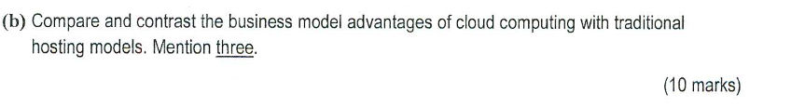infrastructure as a service

Usually use for business, user don’t have to buy hard ware, user have to rent infrastructure from third part provider, set os and calculate by self. Eg. aws

Platform as a service

This is similar with iaas, only different is os and development environment set by third part provider. Eg. Aws elastic beanstalk

Software as a service

User don’t have to install software, usually use browser to use software service. Eg. Google doc.



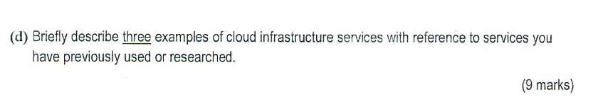

Ec2: this is a web service is use to provide security and scalable computing capacity in cloud.

IAM: is a web service user to security control visit resource of aws.

Rds: is web service it allow user easy to extends, operate and set relational database.

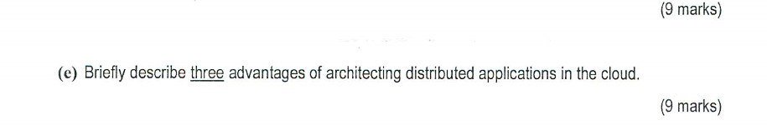



Use to encrypt information, it is role of protecting information security.



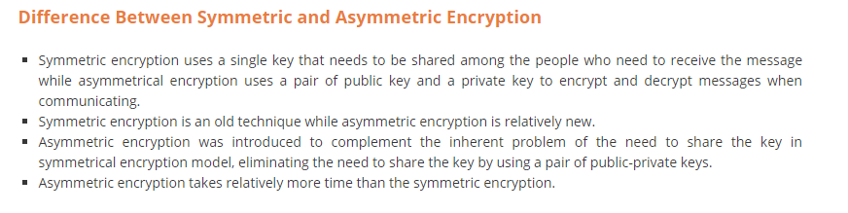



Usually a cloud services can have many service inside, but while run many service they will affect each other, so we can use docker to insulate each service, then each service have own limited cpu, memory and disk, then will not affect each other. Docker can share os and use less resource.



Platform as a service is the third part provider provide infrastructure, os and development environment, and user deploy application.



Platform as a service is the third part provider provide infrastructure, os and development environment, and user deploy application. User can only focus on application code. For example, if i want build a game application in platform as a service, that user can only focus on application code don’t need to set hard ware, os and development environment to calculate.



Aws sqs is a web service, it allow user to access message queue that store the message to to process. Use aws sqs User can quickly to build message queue application on any computer.



